Quick Start Guide

Command-line Interface
These programs can be ran from the command line to perform maintenance on the IGeoS system and to manually execute processing flows.

sia_launch – used to manually execute flows contained in .job files. The syntax is sia_launch example.job. If software updates are available, the program performs their installation prior to execution.
sia_gui starts the Graphical User Interface (below). The interface is used to browse, create, edit, submit processing flows (jobs), monitor their execution, and examine results;
sia_run also starts the Graphical User Interface, but with installation of software updates. This is the preferred way to run the GUI.

In addition, important command-line utilities used for system maintenance are:

sia-update – recompiles, tests, lists components of the system, and also performs automatic software updates;
sia-install installs the system or its parts from remote web repositories.

Graphical Interface
Flows can be constructed, edited and executed entirely from within the GUI. Additionally help is available for the various tools which are included with the system. This guide will explain how to load an example flow, edit its parameters and execute it.
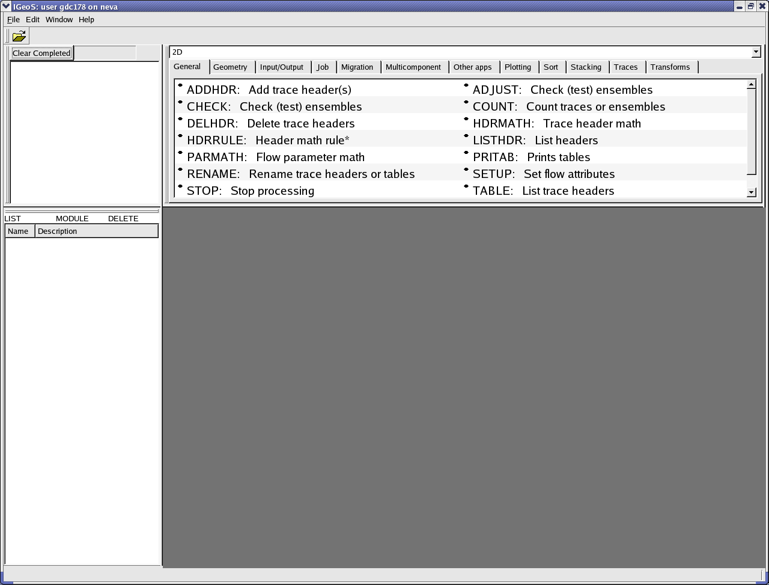
Figure 1 - Main Window

Select “File->Open” from the menu. The project management window will open (Figure 2). By clicking on the + icons: open “Demos”, “Interactive 3D graphics” and “Flows”. Finally, highlight the “Egg carton” flow.
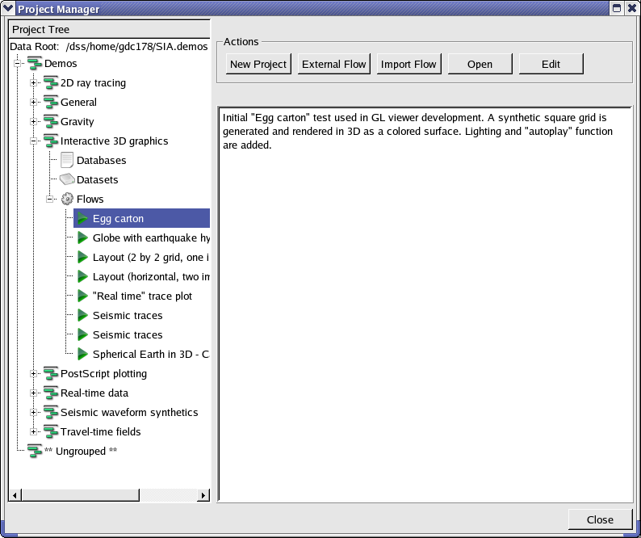
Figure 2 - Project Manager
The pane on the right may contain text to describe the function of the flow. These details can be edited by clicking on the “Edit” button on the upper right of the window. Click on the “Open” button and the flow will be available for editing in the main window (Figure 3).

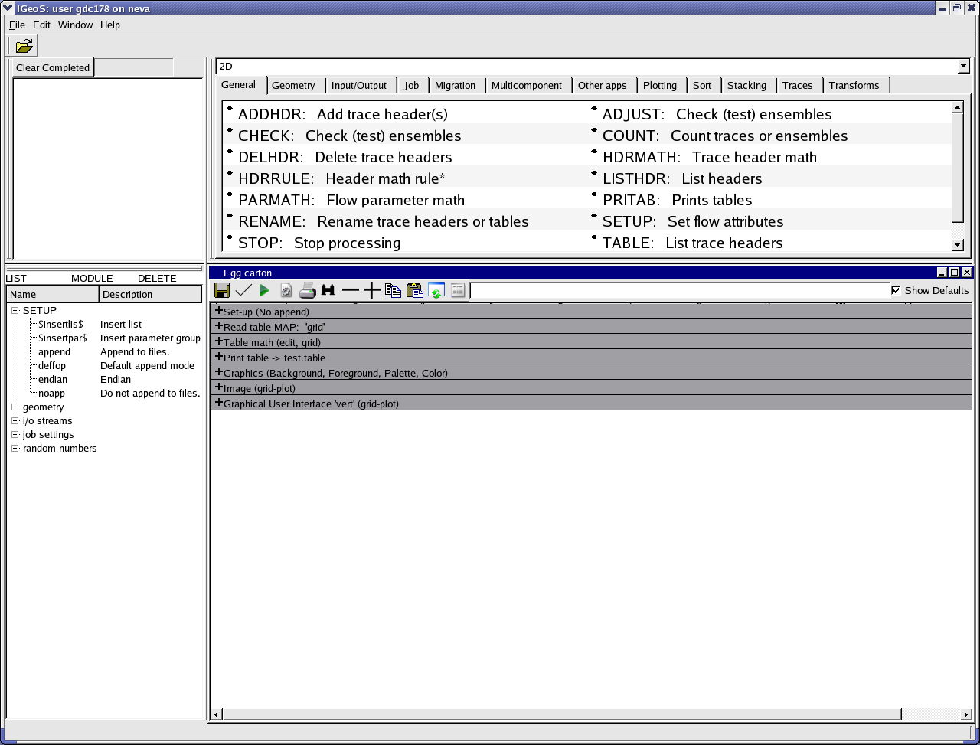
Figure 3 - Flow Loaded in Editor

This flow contains 7 different tools arranged sequentially to produce a certain output. For this job, the output consists in an interactive 3D demo display session.

Pressing the + icon in the flow tool bar will open the parameters of all of the tools. Individual tools and parameters can be expanded by double clicking on their + icon.

Basic flow editing:
- To add a module (processing tool), drag it from the tool library in the upper pane and drop in the appropriate place in the flow. Some tools may then offer a selection of initial parameterizations.
- To add a parameter list (named group of parameters), drag it from the pane on the left;
- To add a module or list by name, drag them into the flow from the corresponding fields MODULE or LIST on the left;
- To delete a module or parameter list, drag it to the field marked DELETE.
- To edit a parameter, click on it and edit using the keyboard or by using drop-down menus.

Flow execution:

To execute the flow, click on the green arrow (“Playback”) in the flow tool box. This flow uses the OpenGL data viewer. It should be started automatically (Figure 4).
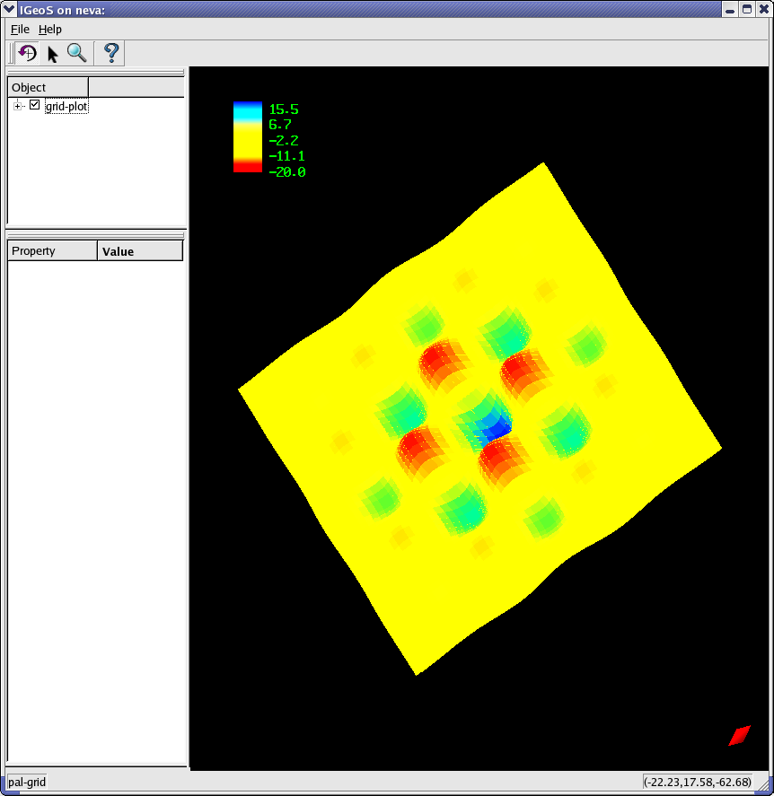
Figure 4 - OpenGL Viewer

Note the four mouse mode control buttons underneath the main “File” menu (Figure 4). The modes are:

- Image rotation and zooming;
- Image editing;
- Zooming and panning (still not implemented);
- Image information (still not implemented).

In rotation mode, the viewer allows rotation by dragging the image. Zoom can be accomplished by scrolling the mouse wheel while clicking on the arrow on the tool bar will place the viewer in interactive mode. Clicks in interactive mode act on the data point under the mouse and are interpreted individually by the various objects. Note that this example does not have any interactive editing capabilities.

Close the viewer window and look again at the flow editor (Figure 5). Note that the job monitor in the upper left of the screen shows that the Egg Carton job has Completed. It can now be cleared from the list by selecting “Clear Completed”.

